TITLE PAGE

**Table of Contents**

Abstract 1

Introduction 1

Chapter 1 Overview on X-ray detection 1

1.1 Sources of characteristic X-rays 1

1.2 Interaction mechanisms of X-rays with matter 2

1.3 X-ray tube 5

1.4 Inorganic semiconducting materials for X-ray detection 8

Chapter 2 Overview on materials 14

Chapter 3 Experimental Methods 15

3.1 MoS2 Samples 15

3.1.1 Fabrication methods 15

3.1.2 IV characterization 15

3.1.3 Characterization under X-rays 15

3.2 TMTES:PS Samples 15

3.2.1 Fabrication methods 15

3.2.2 IV characterization 15

3.2.3 Characterization under X-rays 15

Chapter 4 Results for MoS2 samples 15

Chapter 5 Results for TMTES:PS samples 15

Chapter 6 Conclusions 15

Bibliography 15

# Abstract

Here is the abstract…

# Introduction

This is the Introduction part. Here I include the topic of the thesis, brief description of innovative materials, the goal of the thesis – to understand and to compare two performances of the devices with similar structures, the structure of the thesis.

# Overview on X-ray detection

Ionizing electromagnetic radiation is one of the basic types of radiation along with heavy charged particles, neutron and electron radiation. Particular interest is represented by the photons with the wavelength in the range between 0.1 Å and 1 Å, which constitute so-called X-rays. Such radiation is widely used in material science, crystallography, nuclear medicine, aerospace and in many other technological domains. The physics behind the interaction form the basis for X-ray detection. Therefore, before analyzing specifically the detection mechanisms and devices for X-ray detection, it is essential to study how X-ray photons are created and their interaction with atoms in matter. For this purpose, in this chapter I discuss basic phenomena that serve as X-ray sources, including atom excitation (used in X-ray tubes), excitation by radioactive decay and synchrotron radiation. After that the working principle of an X-ray tube is presented, since this tool was used in my research.

The next section will be dedicated to main mechanisms of interaction between X-ray with absorber atoms, which include photoelectric absorption, Rayleigh scattering etc. Finally, I will briefly discuss currently used X-ray detectors based on inorganic semiconductors, such as silicon (Si), germanium (Ge), gallium arsenide (GaAs) and other conventional semiconducting materials.

## Sources of characteristic X-rays

If the orbital electrons in an atom are disrupted from their normal configuration by some excitation process, the atom may exist in an excited state for a relatively short period of time. Eventually, there is a natural tendency for the orbital electrons to rearrange themselves to return the atom to its lowest energy state (ground state) within a time which is characteristically in the range of nanoseconds for a solid material. The energy emitted in the transition from the excited state to the ground state takes the form of a *characteristic X-ray photon* whose energy is defined as the difference between the initial and the final states of the atom (Knoll, 2010).

A large number of different physical processes can lead to the population of excited atomic states from which characteristic X-rays originate. The most common mechanisms include:

* **Excitation by radioactive decay**

In the nuclear decay process of electron capture, the nuclear charge is decreased by the capture of an orbital electron, most often a *K*-electron. The resulting atom still has the right number of electrons, but the capture process also creates a vacancy in one of the inner shells. Once this vacancy is subsequently filled, characteristic X-rays are generated (Knoll, 2010).

* **Excitation by external radiation**

This method involves an external source of radiation (X-rays, electrons, α-particles etc.) which strikes the target, creating excited or ionized atoms in the target. Since many of these atoms eventually de-excite to the ground state through the emission of characteristic X-rays, the target can serve as a localized source of these X-rays.

As an example, the incident radiation may consist of X-rays generated in a conventional X-ray tube. The external X-rays may then interact with the atoms of a target through photoelectric absorption; therefore, the excited atoms will emit characteristic X-rays creating their X-ray spectrum. This process is called *X-ray fluorescence*.

Another example of incident radiation could be an external electron beam. In this case the characteristic X-ray spectrum from the target will be contaminated by the continuous *bremsstrahlung* spectrum generated by the deceleration of impinging electrons by their interaction with atomic nuclei. For targets of low atomic number, acceleration potentials of only a few thousand volts are required, which allows to use compact electron sources.

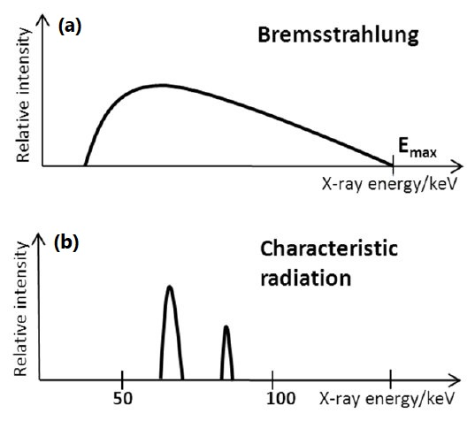

Figure 1.1 Typical X-ray spectrum: (**a**) bremsstrahlung radiation outputs continuous spectrum; (**b**) characteristic radiation spectrum represents discrete peaks (Flay, 2012).

The excitation of a target can also be due to heavy charged particles. The interactions of these particles with the target will give rise to the excited atoms, which will subsequently emit characteristic X-rays. For compact and portable sources, α-particles are often used as incident radiation. As α-particle emitters, 210Po and 244Cm are commonly used (Knoll, 2010).

* **Synchrotron radiation**

X-rays can be also produced by electron beam bent into a circular orbit. According to the electromagnetic theory, a fraction of the beam energy is released when the trajectory of the electrons is deflected within a cycle. When extracted from the accelerator in a tangential direction, the radiation appears as an intense and highly directional beam of photons with the energy ranging from visible light (~eV) to X-rays (~104 eV). Although limited to large-scale centralized user facilities, this unique form of electromagnetic radiation is of great demand because of its high intensity, monoenergetic and tunable radiation energy (Knoll, 2010).

|  |  |
| --- | --- |
| **(a)** | **(b)** |

Figure 1.2 (**a**) Schematic representation of a synchrotron (Synchrotron: Learn its Working Principle, Advantages, & Applications, n.d.); as depicted, different tools can be used for electron beam deflection, which results in X-ray emission. (**b**) A ring-shaped synchrotron ESRF constructed in Grenoble, France (Cho, 2020).

## X-ray tube

In this section I would like to focus more on a specific radiation source – an X-ray tube, that is broadly employed in numerous laboratories and medical departments. Since such device was also used during the experimental part of my research, a comprehensive description of the architecture and working principle of an X-ray tube is necessary to have full perception of how the X-ray measurements were performed.

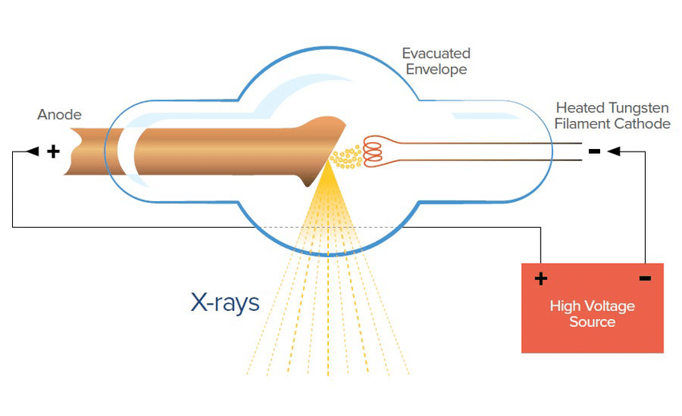

Figure 1.3 Schematic representation of an X-ray tube [1].

As depicted in Fig.1.3, X-rays are generated from the conversion of kinetic energy of electrons into electromagnetic radiation when they become decelerated by interaction with a target material. A high voltage in the range of 20-150 kV is generated between the anode and the cathode of an X-ray tube. (al., 2020). The negative pole of the voltage is applied to the cathode, considered as the source of electrons, and the positive pole is applied to the anode, which is the target for the electrons. In order to eject electrons from the cathode, a current through a filament at the cathode is generated by a separate voltage circuit. The thermionic emission effect causes the filament to heat up and to expel the electrons into vacuum. Once the electrons are ejected, they are accelerated by the X-ray tube voltage and strikes the anode.

At the anode, electrons start to interact with the atoms of the anode. In particular, the positive nuclei start to attract negatively charged electrons, causing their deflection and deceleration and resulting into emission of *bremsstrahlung* X-ray radiation from the anode in different directions. By providing a small window at different angle in the tube, a collimated beam of X-ray photons is obtained (al., 2020), (X-ray Production, Tubes, and Generators, n.d.).

The operational characteristics of an X-ray tube include mainly the voltage and the current between the cathode and the anode. The first one allows to control kinetic energy of the electrons and thus, the energy of generated X-ray photons. The latter is used to tune the number of electrons impinging on the anode and to vary the number of generated photons. Therefore, controlling both these values allows us to establish the desired energy spectra and intensity of X-rays.

Main factors that affect X-ray production efficiency include the kinetic energy of the incident electrons and the atomic number *Z* of the anode (target material). The approximate ratio of radiative energy loss (bremsstrahlung X-rays) to collisional energy loss (excitation of atoms) is the following:

|  |  |
| --- | --- |
|  | 1.1 |

where *Ek* is the kinetic energy of incident electrons (X-ray Production, Tubes, and Generators, n.d.). Most X-ray tube anodes are made of tungsten, due to its high atomic number (*Z* = 74) and exceptionally high melting point of 3422 ℃ (WOLFMET, 2024) with a correspondingly low rate of evaporation. In mammography, molybdenum (*Z* = 42) and rhodium (*Z*=45) are also used. For instance, if we consider incident electrons with kinetic energy of 100 keV impinging on a tungsten anode, the ratio of radiative to collisional losses will be ≈ 0.9%, meaning that more than 99% of the incident electron energy gets converted to heat. Consequently, the heat dissipation problem is a significant concern for employment of X-ray tubes (X-ray Production, Tubes, and Generators, n.d.), (Technologies, 2024).

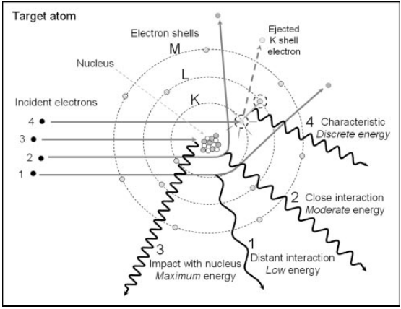

Figure 1.4 Mechanisms of formation of bremsstrahlung radiation and characteristic X-rays. Events 1, 2 and 3 demonstrate the interaction of incident electrons in vicinity of the target nucleus producing bremsstrahlung X-rays by the deceleration and deflection of the electrons through Coulomb interaction. Event 4 depicts emission of characteristic X-rays by ejecting of an orbital electron from the K-shell. An unstable vacancy is formed and an outer shell electron occupies the vacancy emitting energy in the form of a characteristic X-ray photon (Seibert, 204).

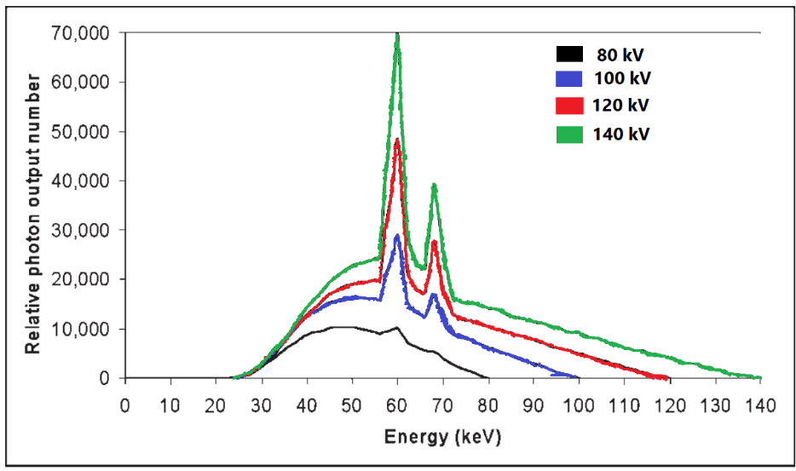

Figure 1.5 Bremsstrahlung and characteristic X-ray energy spectrum for a tungsten anode with the X-ray tube operating at 80, 100, 120 and 140 kV at equal tube current (Seibert, 204).

The X-ray spectrum (Fig. 1.5) output by an X-ray tube consists of discrete characteristic X-rays and continuous bremsstrahlung radiation spectrum with the maximum X-ray energy determined by the potential difference between electrodes. The closer the incident electrons travel to the absorber nucleus, the more intense will be their interaction and the higher will be the emitted photon energy. However, probability of close interaction with the nucleus decreases, thus, decreasing the number of high-energy photons. Therefore, an unfiltered bremsstrahlung radiation energy spectrum is formed the minimum rate at the highest energy and its linear increase with decreasing energy. At the same time low-energy photons are easily attenuated from the beam exiting the X-ray tube window (by Al or Be filters, for example). The measured bremsstrahlung spectrum will have its peak at intermediate energy decreasing to zero at low X-ray energy (Seibert, 204).

Discrete characteristic X-ray spectrum is created by the removal of orbital electrons from the target atoms through their interaction with incident electrons. Each electron shell (denoted by K, L, M etc.) have certain biding energies, which for tungsten are 69.5 keV, 11.5 keV and 2.5 keV for the K, L and M shells, respectively. If a highly energetic incident electron has its kinetic energy of at least 69.5 keV, it can potentially eject a K-shell electron leaving a vacancy in the K-shell. Since the atom becomes energetically unstable, another electron for outer shells (L, M, N etc.) will occupy the vacancy in the K-shell (Fig.1.4, event 4), emitting its energy in the form of an X-ray photon. The energy of the photon is defined as the difference in the binding energies of the K-shell and the outer shell. For example, an electron passing from the L-shell to the K-shell will emit a photon with the energy of 69.5-11.5 = 57.0 keV. Since each element has different electron binding energies, the emitted X-ray energies are characteristic of a specific anode element. These characteristic X-rays will create discrete energy spectrum, which shall be added to the continuous bremsstrahlung spectrum. It is worth noting that characteristic X-rays fully depend on the applied voltage, for example, the K-characteristic radiation from a tungsten anode will occur only of the X-ray tube is operated at voltage of ≥ 69.5 kV. As the tube voltage is increased above the minimum value, characteristic X-ray production will also increase its fraction in the X-ray spectrum (Seibert, 204).

## Interaction mechanisms of X-rays with matter

Although a large number mechanisms of interaction between electromagnetic radiation and matter are known, the three major types are usually taken into consideration:

* Photoelectric absorption
* Compton scattering
* Pair production

The common feature of these interactions is partial or complete transfer of the photon energy to an orbital electron, which results in abrupt disappearance of an impinging photon or change of its trajectory by scattering on the electron (Knoll, 2010). Besides, each interaction mechanism probability depends both on the energy of an impinging photon and the atomic number *Z* of an absorber.

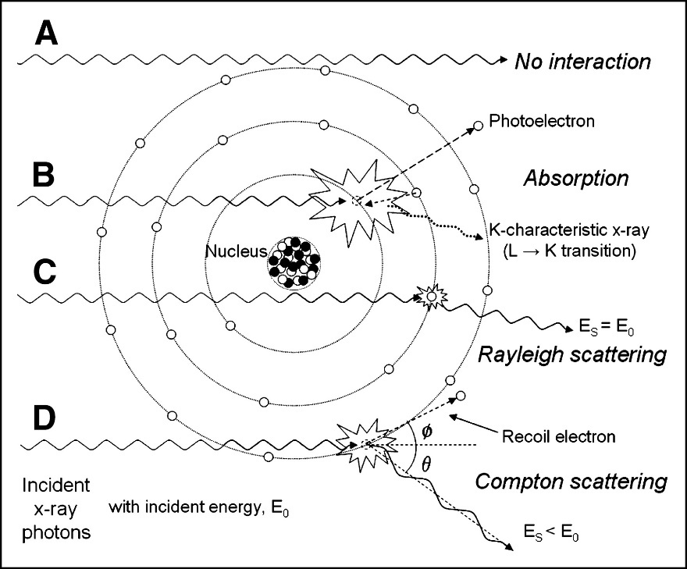

Figure 1.6 Schematic representation of X-ray interactions. (**A**) Incident photons perform no interaction with the absorber material; (**B**) Photoelectric absorption results in total removal of impinging X-ray photon with energy greater than binding energy of an electron in its shell, with excess energy transformed into kinetic energy of the photoelectron; (**C**) coherent (Rayleigh) scattering is the interaction between the photon and an electron (or an atom), in which no energy is exchanged and the photon is deflected from its original direction; (**D**) Compton scattering interactions occur with essentially unbound electrons, with transfer of energy shared between the recoil electron and scattered photon (J, 2005).

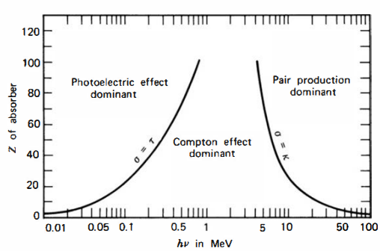

Figure 1.7 Schematic representation of relative probability for different interaction types depending on the *Z* of an absorber atom and on the photon energy *hν*. The lines illustrate the values of *hν* for which the two neighbouring effects are equally probable (Knoll, 2010).

* **Photoelectric absorption**

In the photoelectric absorption process, a photon interacts with an absorber atom, in which the photon passes its energy to an orbital electron and disappears. Instead, an energetic *photoelectron* is ejected by the atom from one of its bound shells. The photoelectron energy is calculated according to the energy conservation law:

|  |  |
| --- | --- |
|  | 1.1 |

where *Eb* is the binding energy of the photoelectron in its original shell. In addition to the photoelectron, the photoelectron absorption also generates an ionized absorber atom with a vacancy in one of its shells. This vacancy is quickly filled through capture of a free electron or rearrangement of electrons from the other shells. As a result, one or more characteristic X-ray photons may be generated. In most cases these X-rays are reabsorbed close to the original site through photoelectric absorption involving less tightly bound shells. However, their possible escape from radiation detectors can influence their response. In some fraction of the cases, the emission of an Auger electron may substitute the characteristic X-ray in carrying away the atomic excitation energy.

According to Fig. 1.7, a photoelectric absorption process is the predominant type of interaction for X-rays (and gamma-rays) of relatively low energy for low-*Z* absorbers. For example, in water photoelectric absorption is dominant up to ~26 keV, while in bones it stays dominant up to ~45 keV (Nett, n.d.). The process is also enhanced for absorber materials of high atomic number *Z*. Although there is no single analytic expression for the probability of photoelectric absorption per atom over all ranges of photon energy *­­Eγ* and *Z*, its rough approximation is present:

|  |  |
| --- | --- |
| where *n* varies between 4 and 5 over gamma-ray energy region (Knoll, 2010). | 1.2 |

* **Compton scattering**

In Compton scattering, the incoming X-ray (or gamma-ray) photon is deflected through an angle *θ* with respect to its original direction (Fig. 1.7) by its interaction with an electron in an absorber atom. The photon transfers a portion of its energy to the electron (assumed to be initially at rest), which is called *recoil electron*. Since any angle of scattering is possible, the energy transferred to the electron can vary from zero to a large fraction of the impinging photon energy (Knoll, 2010).

The expression that relates the energy transfer and the scattering angle can be derived by combining the energy and momentum conservation laws:

|  |  |
| --- | --- |
|  | 1.3 |

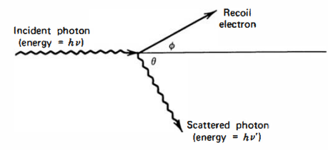

Figure 1.8 Schematic representation of the Compton scattering process (Knoll, 2010).

where *m0c2* is the rest mass energy of the electron (0.511 MeV). The probability of Compton scattering per atom depends on the number of electrons availble as scattering targets and thus, increases linearly with *Z* (Knoll, 2010).

* **Coherent scattering**

In addition to Compton scattering, another type of scattering can occur, when an X-ray (or gamma-ray) photon interacts coherently with an absorber atom. Such *coherent scattering* or *Rayleigh scattering* process neither excites nor ionizes the atom and the scattered photon retains its original energy, although its direction is changed. The probability of Rayleigh scattering is significant only for low photon energies (usually below a few hundred keV for common materials) and in high-*Z* absorbers. Since the average deflection angle decreases with increasing energy, the practical importance of coherent scattering is restricted to low photon energies (Knoll, 2010).

* **Pair production**

If the gamma-ray energy exceeds twice the rest-mass energy of an electron ( MeV), the process of pair production becomes energetically possible. In this interaction (which must take place in the Coulomb field of the nucleus), the gamma-ray photon disappears generating an electron-positron pair. All the excess energy goes into kinetic energy shared by the positron and the electron. Since the positron will subsequently annihilate after slowing down in the absorbing medium, two annihilation photons are normally produced as secondary products of the interaction. No precise expression exists for the probability of pair per nucleus, but its magnitude varies approximately as the square of the absorber atomic number (Knoll, 2010).

* **Absorbed dose**

The mean absorbed radiation energy per unit mass of the absorber is called *absorbed dose*. The SI unit of absorbed dose is defined as *gray* (Gy) which is 1 joule per kilogram. The absorbed dose is a reasonable measure of the chemical or physical effects created by a given radiation exposure in an absorbing material (Knoll, 2010).

## Inorganic semiconducting materials for X-ray detection

The whole multitude of X-ray detection devices might be unified by the principle of creation of charges (free electrons and holes) by absorption of energy due to the passing of X-rays through a material. The most commonly used examples are gas ionization chambers, scintillation counters and semiconductor-based detectors. While the first two types have quite complex configuration, the semiconductor-based devices provide outstanding combination of compact size, high speed, spatial resolution and sensitivity (David Pennicard, 2017). The use of semiconductor materials as radiation detectors can result in a much larger number of carriers for a given incident radiation event that is possible for any other common detector type (Knoll, 2010). The fundamental information carriers are *electron-hole* pairs created by a charged particle or a photon (as primary radiation or its secondary products) in the detector. The motion of generated electrons and holes in an applied electric field generates the basic electrical signal (also called photocurrent) from the semiconductor detector (Knoll, 2010).

Before discussing concrete solid-state X-ray detectors and their architectures, it is good practice to classify the group of semiconductor-based detectors via *direct* and *indirect* detection mechanisms. In the indirect detection, the incident X-ray energy is converted into an electrical signal through a two-step process by using a scintillator material (e.g. CsI or Gd2O2S (A. Datta, 2020)). In the first step the X-ray radiation impinges on a scintillator, which converts the incident radiation into visible photons. In the second step, a photodetector (e.g. a photodiode) converts the visible photons into an electrical signal. In the direct detection, the incoming ionizing radiation is converted into photocurrent directly in a semiconductor material. Since in our research a semiconductor-based device was used to directly generate photocurrent, from now on our discussion will be focused on the semiconductor-based devices employing the direct detection mode (Laura Basiricò, 2021).

In the next paragraphs I will focus on the X-ray detectors based on inorganic semiconductors, leaving devices based on novel material thin-films in the next chapter. The currently used direct detectors can be subsequently classified into two groups depending on the objective of an X-ray measurement. The first class are *spectroscopic* detectors, which are used to measure the energy of X-ray photons without tracking their trajectory through a material. The second group are *imaging* detectors, which are employed to depict an X-ray image (for example, of a patient’s body). In this case spectroscopic detectors are usually composed of a single element, such as a photodiode or a phototransistor (discussed in detail in the next chapter). Imaging detectors, on the other hand, must be spatially multiplied into millions of pixels to obtain precise X-ray image (David Pennicard, 2017).

To provide a good and reliable radiation detection response a direct semiconductor-based X-ray detector should meet the following requirements:

* A small enough band gap that would stimulate the formation of electron-hole pairs and therefore, increase the total photocurrent providing higher signal-to-noise ratio;
* A high atomic number *Z* for better interaction with incident X-ray radiation;
* High resistivity and low leakage current for lower noise current;
* High intrinsic mobility-lifetime *μτ* product to increase the fraction of charge carriers which successfully reach the electrodes before recombination;
* Homogeneous and defect-free medium to enhance charge transport properties;
* Electrodes that would effectively perform charge collection process and would provide a uniform electric field across the medium.

Currently the most commonly used semiconductor-based (or *solid-state*) X-ray detectors are based on inorganic semiconductors, such as silicon, germanium, gallium arsenide, cadmium telluride CdTe and cadmium zink telluride (CZT) (Laura Basiricò, 2021), (David Pennicard, 2017). Based on these materials, different device configurations can be developed. A basic example of an imaging X-ray detector is represented by a strip reverse bias detector used in Particle Physics (Christian W. Fabjan, 2020). Its configuration is composed of numerous small strip-like diodes integrated on the same wafer and connected to its own readout channel. The particle or a photon position is determined by the channel output signal.

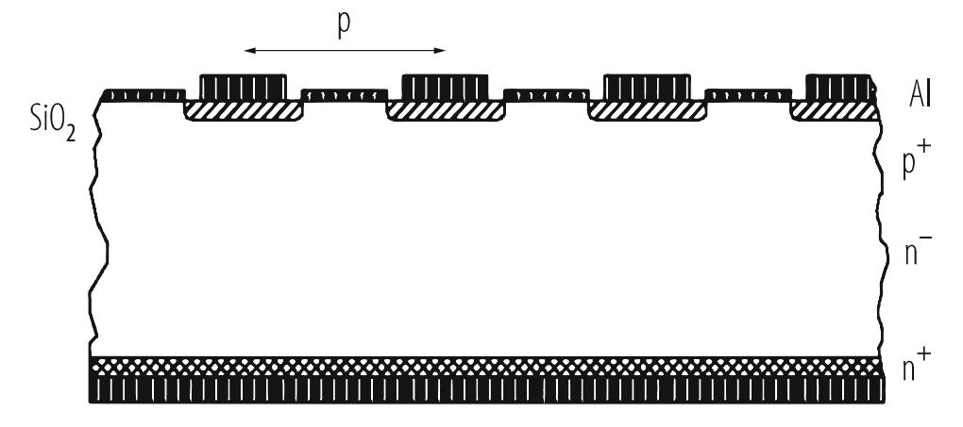

Figure 1.9 Cross section of a Si strip detector built on lightly P-doped (n-) silicon bulk material. Strips are highly B-doped (p+) and the backside is highly P-doped (n+) (Christian W. Fabjan, 2020).

Another imaging detector architecture is represented by the “pixel” structure (Fig.1.7). Here a pixelated semiconductor sensor is connected directly with a silicon readout chip with numerous solder particle array, thus, each sensor pixel is connected to a channel of readout electronics on the chip. Such design allows to acquire direct X-ray detection from each individual pixel creating a whole radiation image (David Pennicard, 2017). The hybrid pixel detector structure is of particular concern, because since the readout chip and sensor are separate, the sensor material can be freely chosen from the available range of valid semiconductor materials. It allows us to subsequently focus on commonly used inorganic semiconductors for the sensor pixel array relying on the same detector architecture (Christian W. Fabjan, 2020), (David Pennicard, 2017).

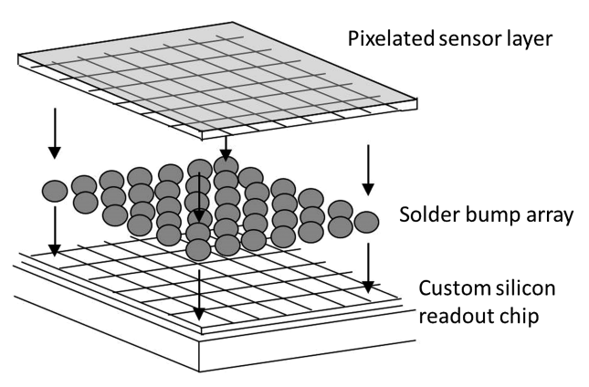

Figure 1.10 Schematic representation of the hybrid pixel detector structure. The pixelated sensor layer is connected to the readout chip with the array of solder bumps. Such structure provides output signal from an individual pixel (David Pennicard, 2017).

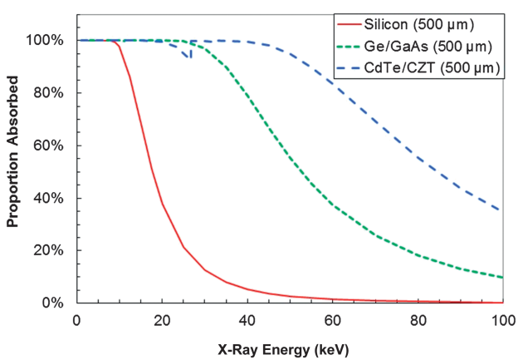

Figure 1.11 Photoelectric X-ray absorption efficiency of common sensor semiconductor materials of 500 µm thickness. The notch in the curve at 30 keV occurs because, while X-ray absorption tends to decrease with increasing photon energy, sudden increase in absorption rate occurs due to photoelectric absorption in the *K*-shell of the atoms (David Pennicard, 2017).

* **Silicon**

Silicon nowadays is the major material used for semiconductor because of verified silicon wafer fabrication, near-perfect crystal homogeneity, robustness and low leakage current in a silicon *pn*-junction. The main disadvantage of the semiconductor is the low detection efficiency due to the low-Z and low attenuation fraction provided (Fig. 1.8, the red curve). For instance, in a 450 µm thick silicon sensor its absorption rate abruptly decreases from 84% to 47% from 12 keV to 17 keV (Silicon Sensors, n.d.). This makes silicon inappropriate for X-ray measurements involving hard X-rays (David Pennicard, 2017).

Efficient detection of hard X-ray photons can be achieved by using germanium, gallium arsenide GaAs, cadmium telluride CdTe and cadmium zinc telluride CZT. On the other hand, the crystal homogeneity of compound semiconductors is typically lower than for a pure element, such as Ge or Si. Besides, higher number of defects in compound semiconductors (Matthew D. McCluskey, 2018) might trap additional amount of charge carriers reducing significant part of photocurrent and altering the electric field applied within the semiconductor medium (Neamen, 2012). Consequently, fabrication of large-pixel sized X-ray detectors using compound semiconductors is limited by their less homogeneous structure.

* **Germanium**

Similarly to silicon, germanium is a single-crystal semiconductor, which can be produced using conventional methods, for example, the Czochralski pulling technique (Ben Depuydt, 2006). The main drawback of this semiconductor is its low band gap energy, which is below 0.7 eV at room temperature (300K) (Kittel, 2005). This significantly increases leakage current from thermally generated charge carriers; therefore, an additional cooling system must be integrated to guarantee a low noise level. Normally, the temperature is reduced to 77 K through the use of an insulated dewar in which a reservoir of liquid nitrogen is kept in thermal contact with the detector (Knoll, 2010).

The germanium-based detector working principle relies on a *pin*-diode structure (David Pennicard, 2017), in which a *p-* and *n-*regions are separated by an intrinsic region to increase the depletion region (Neamen, 2012). The n+ contact can be formed by diffusion of Li atoms into the wafer. The p+ contact on the opposite site is normally made by B implantation (Vetter, 2007).

Although bulkier and more expensive than silicon-based detectors, the single crystal germanium-based detectors, are successfully used in hard X-ray and gamma-ray measurements. Current developments in both sensor technology and readout electronics have led to more compact systems (10-mm-thick Ge layer), demonstrating energy resolutions similar to the silicon detectors, providing an alternative to silicon for a larger energy scale. A large variety of Ge sensor configurations are used for X-ray applications, depending on requirements of a specific experiment. The sensors are generally planar with thickness up to 20 mm with segmentation patterns applied in one or two dimensions (strip or pixel) (David Pennicard, 2017), (Vetter, 2007).

* **Gallium arsenide**

Gallium arsenide (GaAs) has been studied as a radiation detector since the early 1960s. It was the first compound semiconductor operated at room temperature that demonstrated sufficient gamma-ray resolution. At room temperature the band gap energy of GaAs is 1.42 eV (G. Lioliou, 2016), which results in low thermally generated leakage current compared to narrower band gap semiconductors, such as Si and Ge. The average ionization energy of GaAs is 4.3 eV/e-h pair (Knoll, 2010), which indicates that acceptable energy resolution can be provided at room temperature operation. Since the atomic numbers of Ga (*Z=*31) and As (*Z=*33) bracket that of Ge, the expected X-ray and gamma-ray interactions and detection efficiency per unit mass shall be similar to germanium-based sensors. Although GaAs-based detectors output good energy resolution, electric field distortions and charge carrier trapping defects in combination with difficulty of production have prevented the mass realization of bulk GaAs spectroscopic detectors (Knoll, 2010).

Nevertheless, due to relatively wide band gap, GaAs can be used for radiation detection in rough conditions, for example, at high temperatures and at external radiation without the need for cooling system and shielding. GaAs-based detectors are successfully employed in space missions, such as for X-ray fluorescence spectroscopy measurements on Mercury and Jupiter. Another application of GaAs is the electron spectroscopy (G. Lioliou, 2016).

* **Cadmium telluride**

Cadmium telluride (CdTe) is also a high-*Z* semiconductor (*Z=*48 for Cd and 52 for Te) with a sufficiently large band gap energy of 1.52 eV, which makes it appealing material for high-energy X-rays and gamma-rays detection. The probability of photoelectric absorption of gamma-rays per unit pathlength in CdTe is roughly 4-5 times higher than in Ge, and 100 times higher than in Si (Knoll, 2010). On the other hand, poor charge carrier properties and disparity between electrons and holes are typical of CdTe (µeτe = 10-3 cm2V-1 and µhτh = 10-4 cm2V-1). Such low values of mobilities-lifetime products are due to the presence of impurities and defects that act as trapping sites. (L. Abbene S. D., 2014). For example, the mean distance before trapping is on the order of 10 cm for electrons and 1 cm for electrons, which is lower than in Si and Ge (David Pennicard, 2017).

Detector-grade CdTe crystals can be fabricated by first growing polycrystalline CdTe ingots from a Te-rich melt, and then progressively recrystallizing the material by the travelling heater method (THM). Using such approach, single crystal of undoped CdTe can be reliably produced (David Pennicard, 2017). Alternative growth methods may include the Bridgman technique (Knoll, 2010). In order to compensate crystal impurities and defects, CdTe crystals are usually doped with Cl, resulting in high-resistivity *p*-type semiconductor, while the *n*-type crystal is obtained by doping with indium (In) atoms. CdTe detectors are normally fabricated with Schottky contacts using metals with a high work function, such as gold and platinum (Fig.1.9) (L. Abbene S. D., 2014).

CdTe with the *pn-*junction architecture exhibit low leakage current (~nA) even at applied voltage of 100 V. It means that such detectors perform high energy resolution while applying large electric fields to suppress electric field distortions caused by trapping states. However, two main disadvantages limit the success of CdTe sensors as spectroscopic detectors. The first one is called the *polarization* phenomena which represents time instability of a CdTe detector under applied voltage. The polarization phenomena lead to time degradation of the spectroscopic performance of CdTe. One of the methods to minimize the efficiency decrease is the operation of the detector at low temperatures. The second disadvantage of CdTe detectors is the difficulty of fabrication of pixelated structures with the indium electrode for imaging detectors. Aluminum has been found to be appropriate alternative as electrode in pixeled CdTe sensors without increasing leakage current (L. Abbene S. D., 2014).

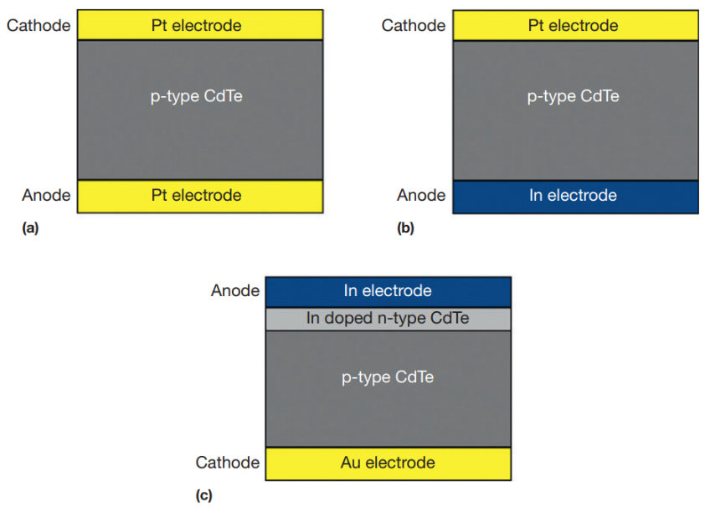

Figure 1.12 Typical CdTe detector configurations: (a) Pt/CdTe/Pt Schottky structure (ohmic contacts); (b) In/CdTe/Pt Schottky structure (rectifying contacts); (c) In/CdTe/Au *pn*-structure (L. Abbene S. D., 2014).

* **Cadmium zinc telluride**

Cadmium zinc telluride (CZT) Cd1-xZnxTe (0<x<0.2) is also considered a good semiconductor for X-ray detection due to its properties, such as: band gap energy of 1.5 eV sufficient to reduce thermally generated noise, thus increasing energy resolution; high atomic number (Cd(48), Zn(30) and Te(52)); absence of negative polarization effect (unlike CdTe); possibility to grow high-resistivity single crystals; relatively good charge transport properties (M. Schieber, 2002). The measured mobilities are 1350 cm2V-1s-1 for electrons and 120 cm2V-1s-1 for holes. Similar to CdTe, the measured lifetime of holes (50-300 ns) is much shorter than that of electrons (100 ns-10 µs) (Knoll, 2010).

Different methods are used for CZT crystal growth. The high-pressure Bridgman technique produces large polycrystalline CZT ingots, which can then be diced to obtain single crystals of a few cubic centimeters. This can provide CZT for spectroscopic detectors, however, imaging detectors usually require larger single-crystal areas. For this purpose, the THM growth technique can be employed (David Pennicard, 2017), (S. Tsigaridas, 2021).

In this section only a few commonly used inorganic semiconducting materials were described. More broad variety shall also include silicon carbide (SiC), mercuric iodide (HgI2), diamond and other crystalline semiconductors. Even though these materials provide satisfactory performance for X-ray detection, they still suffer from numerous limitations, such as mechanical rigidity, stiffness and difficulty to grow large-scale crystalline structures, which prevents their employment onto flexible widespread substrates. This makes the inorganic solid-state detectors impossible to deposit them onto curved surfaces making them inappropriate to some specific applications such as personal dosimetry during radiological measurements.

For this reason, scientific community is actively developing novel semiconducting materials that would provide efficient detection performance, in combination with flexibility, large-scale and low-cost production of semiconductor-based X-ray detectors. The goal of the next chapter is to provide a thorough review on specific semiconductors that are being currently examined as prominent materials for thin-film X-ray detectors.

# Overview on materials

Here I discuss the semiconducting materials for the active channel: MoS­2 and TMTES:PS.

# Experimental Methods

## MoS2 Samples

### Fabrication methods

### IV characterization

### Characterization under X-rays

## TMTES:PS Samples

### Fabrication methods

### IV characterization

### Characterization under X-rays

# Results for MoS2­ samples

# Results for TMTES:PS samples

# Conclusions

# Bibliography

(2024, February 05). Retrieved from WOLFMET: https://www.wolfmet.com/tungstenalloys

A. Datta, Z. Z. (2020). A new generation of direct X-ray detectors for medical and synchrotron imaging applications. *Scientific Reports*.

al., S. P. (2020). Production of X-RAYS using X-RAY Tube. *Journal of Physics: Conference Series*.

Ben Depuydt, A. T. (2006). Germanium: From the first application of Czochralski crystal growth to large diameter dislocation-free wafers. In *Materials Science in Semiconductor Processing* (pp. 437-443).

Christian W. Fabjan, H. S. (2020). *Particle Physics Reference Library, Volume 2: Detectors for Particles and Radiation.* Vienna, Austria: Springer.

David Pennicard, B. P. (2017). Semiconductor materials for X-ray detectors. *MRS Bulletin*.

G. Lioliou, A. B. (2016). Gallium Arsenide detectors for X-ray and electron (beta particle) spectroscopy. *Nuclear Instruments and Methods in Physics Reasearch A*, 37-45.

Kittel, C. (2005). Introduction to Solid State Physics, Eighth Edition. John Wiley & Sons, Inc.

Knoll, G. F. (2010). *Radiation detection and measurement; 4th ed.* New York, NY: Wiley.

L. Abbene, f. P. (2019). Room-temperature X-ray response of cadmium-zinc-telluride pixel detectors grown by the vertical Bridgman technique. *Journal of synchrotron radiation*.

L. Abbene, S. D. (2014). CdTe Detectors. In *Comprehensive Biomedical Physics* (pp. 285-314). Elseiver .

Laura Basiricò, A. C. (2021). Solution-Grown Organic and Perovskite X-Ray Detectors: A New Paradigm for the Direct Detection of Ionizing Radiation. *Adv. Mater. Technol.*

M. Schieber, T. S. (2002). Study of impurity segregation, crystallinity and detector performance of melt-grown cadmium zinc telluride crystals. *Journal of Crystal Growth*, 2082-2090.

Matthew D. McCluskey, E. E. (2018). Dopants and defects in semiconductors, Second Edition. CRC Press.

Neamen, D. A. (2012). Semiconductor Physics and Devices: Basic Principles, Fourth Edition.

S. Tsigaridas, S. Z. (2021). Fabrication of Small-Pixel CdZnTe Sensors and Characterization with X-rays. *Sensors*.

Seibert, J. A. (204). X-ray imaging physics for nuclear medicine technologists. Part 1: Basic principles of x-ray production. *Nuclear Medicine Technology*.

*Silicon Sensors*. (n.d.). Retrieved from DECTRIS: https://www.dectris.com/en/technology/sensors/silicon-sensors/

Technologies, O. I.-r. (2024, February 05). *Managing the Heat Produced by X-ray Tubes*. Retrieved from https://xray.oxinst.com/learning/view/article/managing-the-heat-produced-by-x-ray-tubes

Vetter, K. (2007). Recent Developments in the Fabrication and Operation of Germanium Detectors.

*X-ray Production, Tubes, and Generators*. (n.d.). Retrieved from Radiology Key: https://radiologykey.com/x-ray-production-tubes-and-generators